DAY13

Class Exercise

    @PostMapping("/book/author/{authorId}")

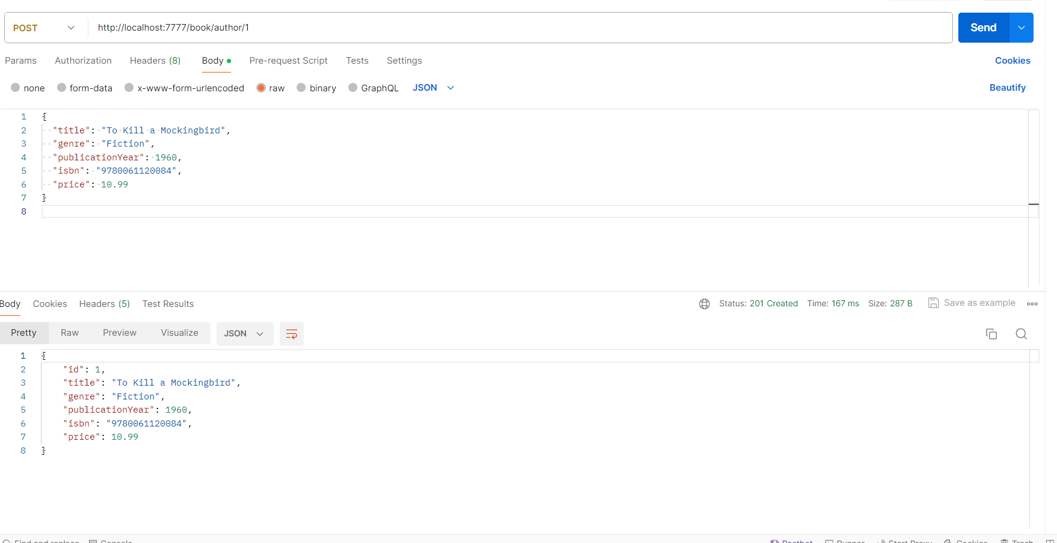

    @GetMapping("/author")

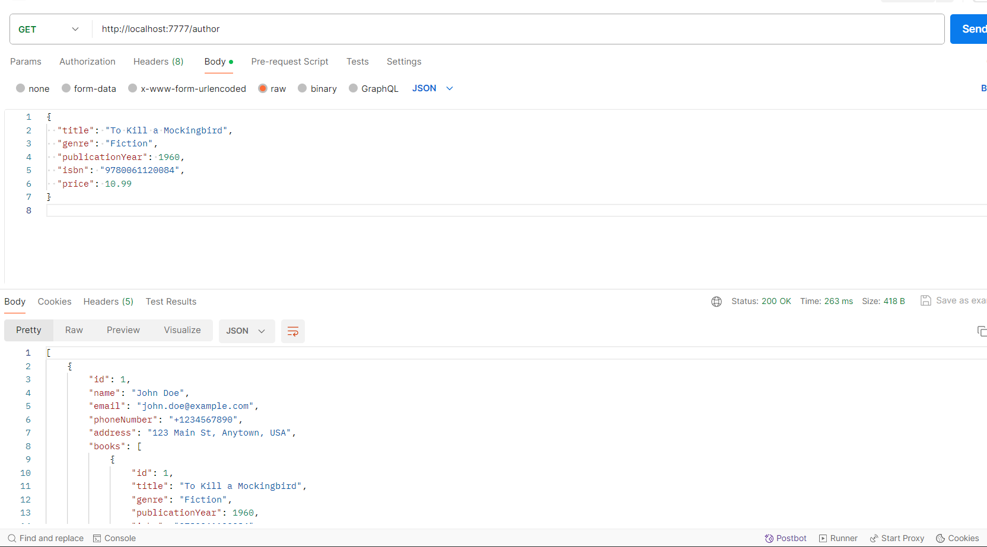

    @GetMapping("/author/{authorId}")

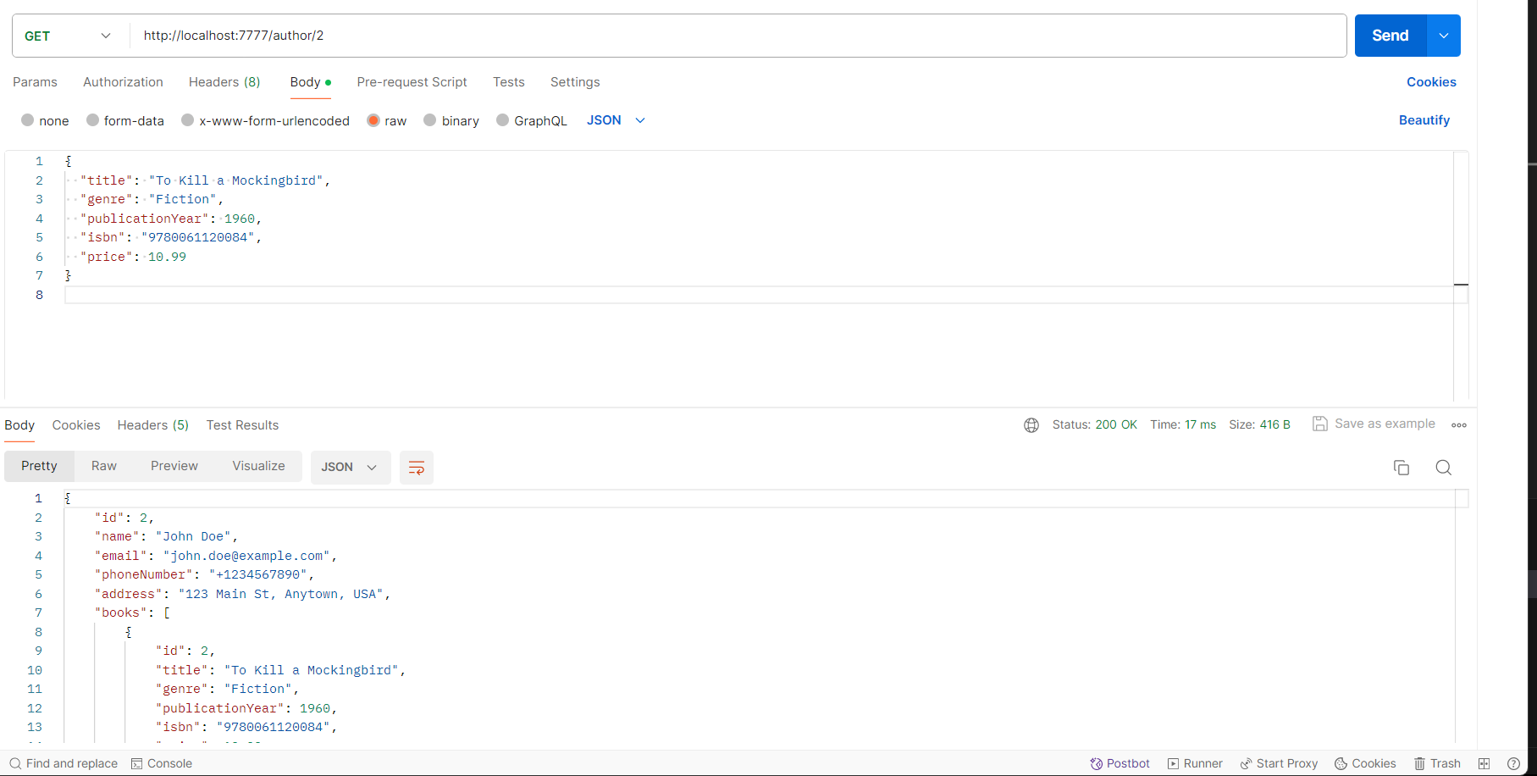

    @PutMapping("/author/{authorId}")

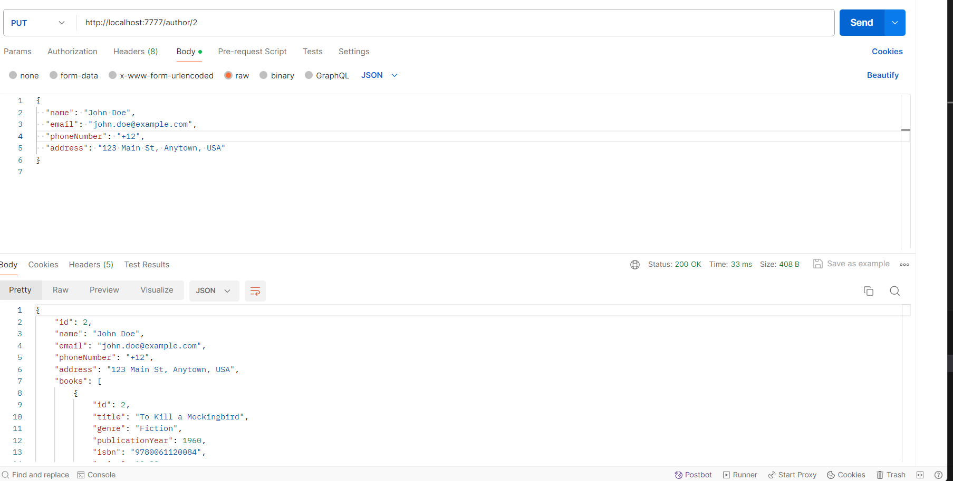

    @DeleteMapping("/book/{bookId}")

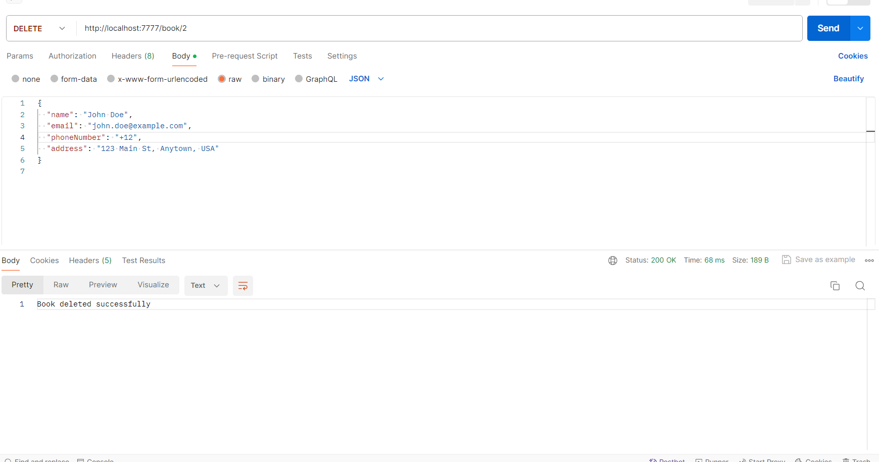

    @GetMapping("/book/{bookId}")

